A: Anaerobic Exercise
Q: How are ingredients listed on food labels?
A: In order of abundance
Q: What is Hunger?
A: a physical need for food.

Q: An example of a nutrient dense food.
A: Carrots

Q: What 3 essential nutrients give you energy/calories.

A: Carbohydrates (4), Protein (4), and Fats (9).

Q: Range that helps people know the intensity they are exercising at.
A: Target Heart Rate

Q: Lipids that are liquid at room temperature.

A: Unsaturated Fats

Q: Found in complex carbs, and helps your digestive tract.

A: Fiber

Q: How long a muscle can do an activity before it gets tired.
A: Muscular endurance

Q: A ratio of height to weight.

A: Body Mass Index (BMI)

Q: These are not made by the body.

A: 9 Essential Amino Acids

Q: If you take in more calories than you burn, what will happen?
A: Your amount of stored body fat might increase.

Q: The way you see your body.

A: Body Image

Q: Characterized by an intense fear of gaining weight and a distorted body image.

A: Anorexia Nervosa
Q: Ration of lean body tissue to body fat.

A: Body Composition

Q: Purging the digestive system following overeating.

A: Bulimia Nervosa

Q: What are Fat-Soluble Vitamins?

A: Are absorbed by fat.

Q: What is obesity?

A: An excessive amount of body fat.
Q: What is metabolism?

A: How the food you eat, gives you energy.
Q: What are some examples of cardio respiratory endurance.

A: Running, Biking, and Swimming.

Q: What is the leading cause of death in the U.S.?

A: Cardiovascular disease

Q: What is this?
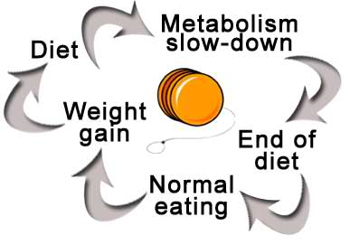

A: The yo-yo effect of dieting.

Q: Liquid diets, diet supplements, diet pills, and fasting are what?

A: Types of fad diets.

Q: What influences body image?

A: Media, Family, Peers

Q: What is binge eating?

A: Characterized by frequent episodes of uncontrollable eating.
Q: Activities that are maintained for 10 or more minutes.

A: Aerobic Exercise

Q: Activities that are done in short bursts.

